Problem Statement:

the below linux commands with an example. Share the screenshot of each command with the output:

1. pwd

PWD: ‘pwd‘ stands for ‘Print Working Directory‘. As the name states, command ‘pwd‘ prints the current working directory or simply the directory user is, at present. It prints the current directory name with the complete path starting from root (/). This command is built in shell command and is available on most of the shell – bash, Bourne shell, ksh,zsh, etc.

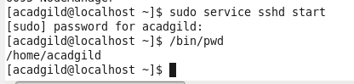

2. vi

**vi** is an interactive text editor which is *display-oriented*: the screen of you terminal acts as a window into the file you are editing. Changes you make to the file are reflected in what you see.

Using **vi** you can insert text anywhere in the file very easily.

Most of the **vi** commands move the courser  around in the file. You can move the cursor forward and backward in units of characters, words, sentences, and paragraphs. Some of the operators, like **d** for delete and **c** for change, can be combined with the motion commands to make them operate on entire words, paragraphs, etc., in a natural way.

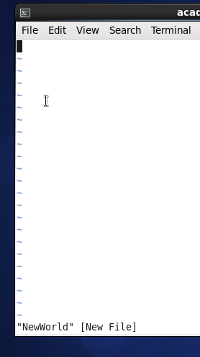

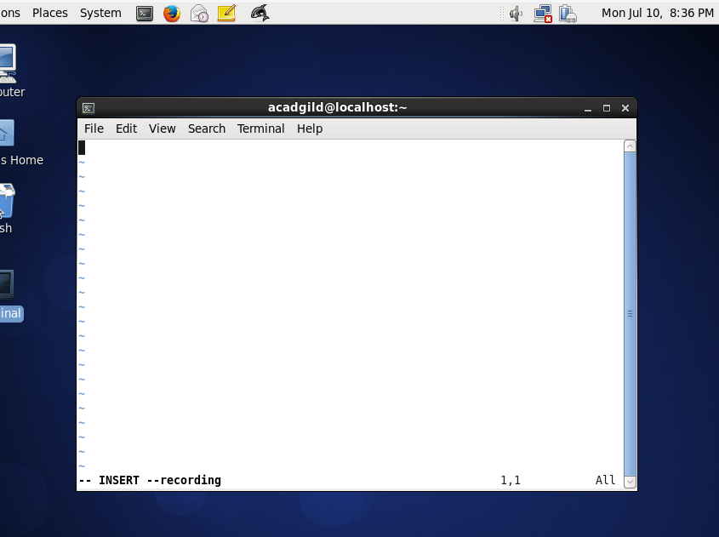

3. touch

**touch** is a standard **Unix command**-line interface program which is used to update the access date and / or modification date of a file or directory. In its default usage, it is the equivalent of creating or opening a file and saving it without any change to the file contents.

The **touch command** can be used to modify the access/modification timestamps of files. It is more often used to actually just create an empty file quickly.

1. -a, change the access time only
2. -c, if the file does not exist, do not create it
3. -d, update the access and modification times
4. -m, change the modification time only
5. -r, use the access and modification times of file
6. -t, creates a file using a specified time

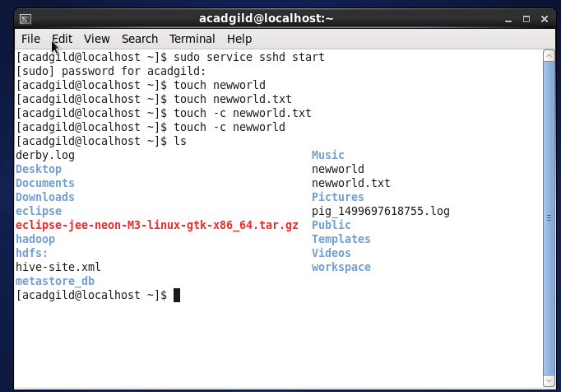

4. mkdir

The mkdir command is is used to create new directories. A **directory**, referred to as a folder in some operating systems, appears to the user as a container for other directories and files

The mkdir command in UNIX allows users to create directories or folders as they are referred to in some operating systems. The mkdir command can create multiple directories at once and also set permissions when creating the directory. The user running the command must have appropriate permissions on the parent directory to create a directory or will receive a permission denied error.

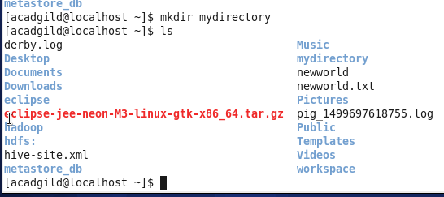

5. rm

rm linux command is used to remove/delete the file from the directory.

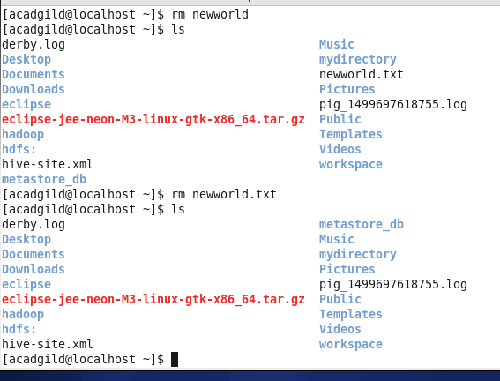

rm to remove the directory

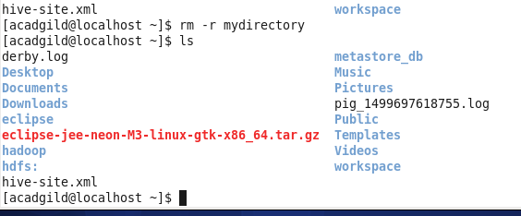

6. ls

In order to list all files and directories using an SSH client, you would need to execute the appropriate command. The command name

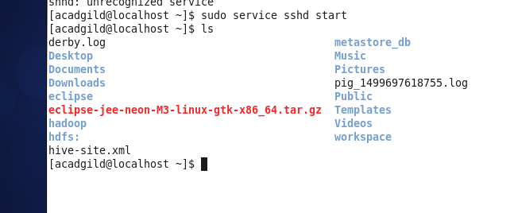

7. echo

echo is a built-in [command](http://www.linfo.org/command.html) in the bash and C [shells](http://www.linfo.org/shell.html) that writes its [arguments](http://www.linfo.org/argument.html) to [standard output](http://www.linfo.org/standard_output.html).

The syntax for echo is

echo [option(s)] [string(s)]

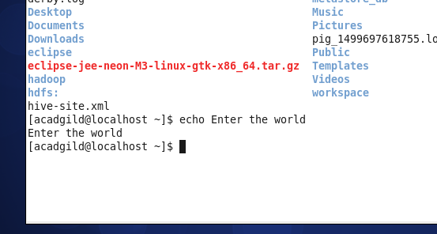

8. cat

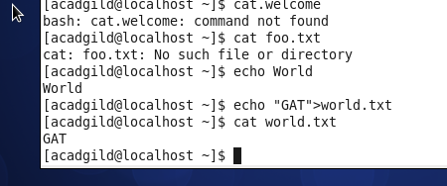

9. who

The **who** command prints information about all users who are currently logged in.

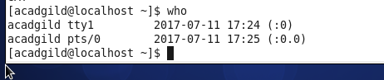

10. cd

The **cd** command is one of the commands you will use the most at the [command line](https://www.computerhope.com/jargon/c/commandi.htm) in linux. It allows you to change your [working directory](https://www.computerhope.com/jargon/c/currentd.htm). You use it to move around within the [hierarchy](https://www.computerhope.com/jargon/h/hierfile.htm) of your [file system](https://www.computerhope.com/jargon/f/filesyst.htm).

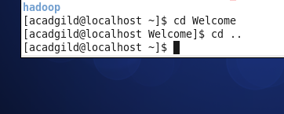

11. date

The date command is used to print out, or change the value of, the system's time and date information.

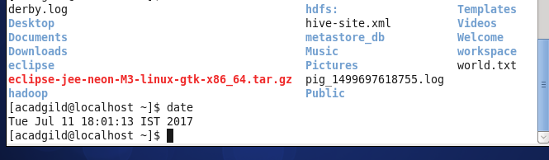

12. cal

Display a conveniently-formatted calendar from the command line.

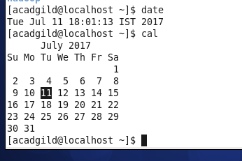

13. mv

The mv command is used to move or [rename](https://www.computerhope.com/jargon/r/rename.htm)files.

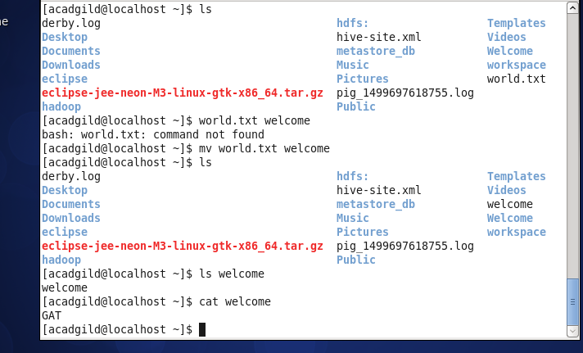

14. cp

The cp command is used to make copies of files and directories.

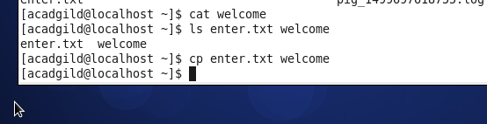

15. which

Locate the [executable file](https://www.computerhope.com/jargon/e/execfile.htm) associated with a given [command](https://www.computerhope.com/jargon/c/command.htm).

